# Ideation Phase Define the Problem Statements

|  |  |
| --- | --- |
| Date | 03 NOVEMBER 2022 |
| Team ID | PNT2022TMID13299 |
| Project Name | Gas leakage monitoring and alerting system for industries |
| Maximum Marks | 2 Marks |

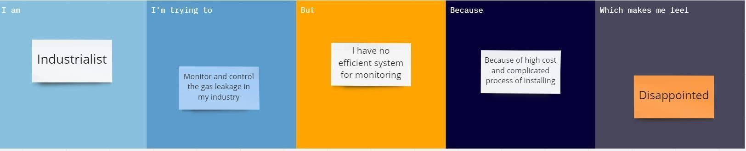

|  |  |  |  |  |  |
| --- | --- | --- | --- | --- | --- |
| Problem  Statement  (PS) | I am  (Customer) | I am trying to | But | Because | Which makes me  Feel |
| PS-1 | Industrialist | Monitor gas leakage in the industry | I don’t have any system for monitoring | The affordable of the system is high and the systems are sometimes making disasters | Unsafe |
| PS-2 | Industrialist | Control the gas leakage | Also, the installation process is too complicated | The number of sensors is unpredictable and the positioning of equipment is improper | Disastrous |